Integrating the Healthcare Enterprise



IHE Patient Care Coordination (PCC) Technical Framework Supplement
2009-2010

Pre-Hospital Patient Care Report (PCR)

F2F Review
Volume 1 DRAFT - January 29, 2008

Foreword
Integrating the Healthcare Enterprise (IHE) is an initiative designed to stimulate the integration of the information systems that support modern healthcare institutions. Its fundamental objective is to ensure that in the care of patients all required information for medical decisions is both correct and available to healthcare professionals. The IHE initiative is both a process and a forum for encouraging integration efforts. It defines a technical framework for the implementation of established messaging standards to achieve specific clinical goals. It includes a rigorous testing process for the implementation of this framework. And it organizes educational sessions and exhibits at major meetings of medical professionals to demonstrate the benefits of this framework and encourage its adoption by industry and users.
The approach employed in the IHE initiative is not to define new integration standards, but rather to support the use of existing standards, HL7, DICOM, IETF, and others, as appropriate in their respective domains in an integrated manner, defining configuration choices when necessary. IHE maintain formal relationships with several standards bodies including HL7, DICOM and refers recommendations to them when clarifications or extensions to existing standards are necessary.
This initiative has numerous sponsors and supporting organizations in different medical specialty domains and geographical regions. In North America the primary sponsors are the Healthcare Information and Management Systems Society (HIMSS) and the Radiological Society of North America (RSNA). IHE Canada has also been formed. IHE Europe (IHE-EUR) is supported by a large coalition of organizations including the European Association of Radiology (EAR) and European Congress of Radiologists (ECR), the Coordination Committee of the Radiological and Electromedical Industries (COCIR), Deutsche Röntgengesellschaft (DRG), the EuroPACS Association, Groupement pour la Modernisation du Système d'Information Hospitalier (GMSIH), Société Francaise de Radiologie ([www.sfr-radiologie.asso.fr SFR]), and Società Italiana di Radiologia Medica (SIRM). In Japan IHE-J is sponsored by the Ministry of Economy, Trade, and Industry (METI); the Ministry of Health, Labor, and Welfare; and [www.medis.or.jp MEDIS-DC]; cooperating organizations include the Japan Industries Association of Radiological Systems (JIRA), the Japan Association of Healthcare Information Systems Industry (JAHIS), Japan Radiological Society (JRS), Japan Society of Radiological Technology (JSRT), and the Japan Association of Medical Informatics (JAMI). Other organizations representing healthcare professionals are actively involved and others are invited to join in the expansion of the IHE process across disciplinary and geographic boundaries.
The IHE Technical Frameworks for the various domains (Patient Care Coordination, IT Infrastructure, Cardiology, Laboratory, Radiology, etc.) define specific implementations of established standards to achieve integration goals that promote appropriate sharing of medical information to support optimal patient care. It is expanded annually, after a period of public review, and maintained regularly through the identification and correction of errata. The current version for these Technical Frameworks may be found at www.ihe.net/Technical_Framework.
The IHE Technical Framework identifies a subset of the functional components of the healthcare enterprise, called IHE Actors, and specifies their interactions in terms of a set of coordinated, standards-based transactions. It describes this body of transactions in progressively greater depth. The volume I provides a high-level view of IHE functionality, showing the transactions organized into functional units called Integration Profiles that highlight their capacity to address specific clinical needs. The subsequent volumes provide detailed technical descriptions of each IHE transaction.

This IHE Patient Care Coordination (PCC) Technical Framework Supplement is issued for Trial Implementation through May 2010.

Comments and change proposals arising from Trial Implementation may be submitted to http://forums.rsna.org under the forum:
“Integrating the Healthcare Enterprise”
Select the sub-forum:
“IHE Patient Care Coordination 2009 Supplements for Trial Implementation”

The IHE IT Infrastructure Technical Committee will address these comments resulting from implementation, Connectathon testing, and demonstrations. Final text is expected to be published in June 2010, dependent upon results of IHE validation process.

Table of Contents
Pre-Hospital Patient Care Report (PCR)
1
1 Foreword 2
Table of Contents 4
1.1 Preface to Volume 1 of the PCC Technical Framework 6
2 Introduction 10
2.1 Relationship to Standards 10
2.2 Relationship to Product Implementations 11
2.3 Framework Development and Maintenance 11
2.4 About the Patient Care Coordination Integration Profiles 12
2.5 Dependencies of the PCC Integration Profiles 13
2.6 PCC Integration Profiles Overview 15
2.7 History of Annual Changes 18
2.8 Product Implementations 19
3 Pre-Hospital Patient Care Report (PCR) 21
3.2 Profile Abstract 21
3.3 Dependencies 22
3.4 Overview 22
3.5 Use Cases 23
3.6 Actors/Transaction 26
3.7 Options 26
3.8 Grouping 26
3.9 Content Modules 27
3.10 Process Flow 28
Actor Descriptions 28
Transaction Descriptions 29
How to Prepare an IHE Integration Statement 29
A.1 Structure and Content of an IHE Integration Statement 30
A.2 Format of an IHE Integration Statement 31
Glossary 32

Content of the Technical Framework
This technical framework defines relevant standards and constraints on those standards in order to implement a specific use cases for the transfer of information between systems. This document is organized into 2 volumes as follows:
Volume 1 - Overview
This volume is provided as a high level overview of the profiles including descriptions of the use case, the actors involved, the process flow, and dependencies on other standards and IHE profiles. It is of interest to care providers, vendors' management and technical architects and to all users of the profile
Volume 2 – Transactions and Content Profiles
This volume is intended as a technical reference for the implementation of specific transactions in the use case including references to the relevant standards, constraints, and interaction diagrams. It is intended for the technical implementers of the profile.
How to Contact Us
IHE Sponsors welcome comments on this document and the IHE initiative. They should be directed to the discussion server at http://forums.rsna.org or to:
Didi Davis
Senior Director of Integrating the Healthcare Enterprise (IHE)
HIMSS
230 East Ohio St., Suite 500
Chicago, IL 60611
Email: ihe@himss.org

Preface to Volume 1 of the PCC Technical Framework

Intended Audience
The intended audience of this document is:
- Pre-Hospital healthcare professionals involved in informatics
- IT departments of pre-hospital patient care report system providers
- Technical staff of vendors participating in the IHE initiative
- Experts involved in standards development
- Those interested in integrating pre-hospital patient care report systems and workflows

Related Information for the Reader
The reader of volume 1 should read or be familiar with the following documents:
- Volume 1 of the Cross-Enterprise Document Sharing (XDS) Integration Profile documented in the ITI Infrastructure Technical Framework
- Volume 1 of the Notification of Document Availability (NAV) Integration Profile documented in the ITI Infrastructure Technical Framework
- Volume 1 of the Audit Trail and Node Authentication (ATNA) Integration Profile documented in the ITI Infrastructure Technical Framework
(See http://www.ihe.net/Technical_Framework/index.cfm ).
- HL7 Clinical Document Architecture Release 2: Section 1, CDA Overview.
- Care Record Summary – Implementation Guide for CDA Release 2 (US Realm): Section 1
- Presentations from IHE Workshop: Effective Integration of the Enterprise and the Health System - June 28–29, 2005: http://www.ihe.net/Participation/workshop_2005.cfm, June 2005:
- Leveraging IHE to Build RHIO Interoperability
- Cross-Enterprise Document Sharing (XDS)
- Notification of Document Availability (NAV)
- Patient Care Coordination
- Use Cases for Medical Summaries
- Patient Care Coordination - Overview of Profiles

How this Volume is Organized
Section 2 describes the general nature, structure, purpose and function of the Technical Framework. Section 3 and the subsequent sections of this volume provide detailed documentation on each integration profile, including the Patient Care Coordination problem it is intended to address and the IHE actors and transactions it comprises.
The appendices following the main body of the document provide a summary list of the actors and transactions, detailed discussion of specific issues related to the integration profiles and a glossary of terms and acronyms used.

Conventions Used in this Document
This document has adopted the following conventions for representing the framework concepts and specifying how the standards upon which the IHE Technical Framework is based should be applied.

Technical Framework Cross-references
When references are made to another section within a Technical Framework volume, a section number is used by itself. When references are made to other volumes or to a Technical Framework in another domain, the following format is used:
<domain designator> TF-<volume number>: <section number>
where:
<domain designator>
is a short designator for the IHE domain (PCC= Patient Care Coordination, ITI = IT Infrastructure, RAD = Radiology)
<volume number>
is the applicable volume within the given Domain Technical Framework (e.g., 1, 2, 3), and
<section number>
is the applicable section number.
For example: PCC TF-1: 3.1 refers to Section 3.1 in volume 1 of the IHE Patient Care Coordination Technical Framework, ITI TF-2: 4.33 refers to Section 4.33 in volume 2 of the IHE IT Infrastructure Technical Framework.

IHE Actor and Transaction Diagrams and Tables
Each integration profile is a representation of a real-world capability that is supported by a set of actors that interact through transactions. Actors are information systems or components of information systems that produce, manage, or act on categories of information required by operational activities in the enterprise. Transactions are interactions between actors that communicate the required information through standards-based messages.
The diagrams and tables of actors and transactions in subsequent sections indicate which transactions each actor in a given profile must support.
The transactions shown on the diagrams are identified both by their name and the transaction number as defined in PCC TF-2 (Volume 2 of the PCC Technical framework). The transaction numbers are shown on the diagrams as bracketed numbers prefixed with the specific Technical Framework domain.
In some cases, a profile is dependent on a prerequisite profile in order to function properly and be useful. For example, Cross-Enterprise Sharing of Medical Summaries depends on Audit Trail and Node Authentication (ATNA). These dependencies can be found by locating the desired profile in the dependencies section of this document to determine which profile(s) are listed as prerequisites. An actor must implement all required transactions in the prerequisite profiles in addition to those in the desired profile.

Process Flow Diagrams
The descriptions of integration profiles that follow include process flow diagrams that illustrate how the profile functions as a sequence of transactions between relevant actors.
These diagrams are intended to provide an overview so the transactions can be seen in the context of an institution’s or cross-institutions’ workflow. Certain transactions and activities not defined in detail by IHE are shown in these diagrams in italics to provide additional context on where the relevant IHE transactions fit into the broader scheme of healthcare information systems. These diagrams are not intended to present the only possible scenario. Often other actor groupings are possible, and transactions from other profiles may be interspersed.
In some cases the sequence of transactions may be flexible. Where this is the case there will generally be a note pointing out the possibility of variations. Transactions are shown as arrows oriented according to the flow of the primary information handled by the transaction and not necessarily the initiator.

Copyright Permissions
Health Level Seven, Inc., has granted permission to the IHE to reproduce tables from the HL7 standard. The HL7 tables in this document are copyrighted by Health Level Seven, Inc. All rights reserved. Material drawn from these documents is credited where used.
IHE has been very fortunate in having the National Association of State EMS Officials and (NASEMSO) National EMS Information Systems (NEMSIS) help us in the definition of the data found in the Pre-Hospital Patient Care Report (PCR).
The Pre-Hospital Patient Care Report Profile (PCR) describes the content structures and specifications the National Association of State EMS Officials and (NASEMSO) National EMS Information Systems (NEMSIS) views are necessary in a pre-hospital patient care report. NASEMSO and NEMSIS encourage the use of the content structures contained in the Profile of the Patient Care Coordination Technical Framework. ACOG does not endorse any EMR products. Companies or individuals that use these content structures in EMR product or service are prohibited from using ACOG's name and/or its logo on any promotional material, packaging, advertisement, website or in any other context related to the EMR product or service.

Introduction
This document, the IHE Patient Care Coordination Technical Framework (PCC TF), defines specific implementations of established standards. These are intended to achieve integration goals that promote appropriate exchange of medical information to coordinate the optimal patient care among care providers in different care settings. It is expanded annually, after a period of public review, and maintained regularly through the identification and correction of errata. The latest version of the document is always available via the Internet at http://www.ihe.net/Technical_Framework/ , where the technical framework volumes specific to the various healthcare domains addressed by IHE may be found.
The IHE Patient Care Coordination Technical Framework identifies a subset of the functional components of the healthcare enterprises and health information networks, called IHE actors, and specifies their interactions in terms of a set of coordinated, standards-based transactions. The other domains within the IHE initiative also produce Technical Frameworks within their respective areas that together form the IHE Technical Framework. Currently, the following IHE Technical Framework(s) are available:
- IHE IT Infrastructure Technical Framework
- IHE Cardiology Technical Framework
- IHE Laboratory Technical framework
- IHE Radiology Technical Framework
- IHE Patient Care Coordination Technical Framework
Where applicable, references are made to other technical frameworks. For the conventions on referencing other frameworks, see the preface of this volume.

Relationship to Standards
The IHE Technical Framework identifies functional components of a distributed healthcare environment (referred to as IHE actors), solely from the point of view of their interactions in the healthcare enterprise. It further defines a coordinated set of transactions based on standards (such as HL7, IETF, ASTM, DICOM, ISO, OASIS, etc.) in order to accomplish a particular use case. As the scope of the IHE initiative expands, transactions based on other standards may be included as required.
At its current level of development, IHE has also created Content Integration Profiles to further specify the payloads of these transactions, again based on standards. This has become necessary as the healthcare industry moves towards the use of transaction standards that have been used in more traditional computing environments.
In some cases, IHE recommends selection of specific options supported by these standards. However, IHE does not introduce technical choices that contradict conformance to these standards. If errors in or extensions to existing standards are identified, IHE’s policy is to report them to the appropriate standards bodies for resolution within their conformance and standards evolution strategy.
IHE is therefore an implementation framework, not a standard. Conformance claims for products must still be made in direct reference to specific standards. In addition, vendors who have implemented IHE integration capabilities in their products may publish IHE Integration Statements to communicate their products’ capabilities. Vendors publishing IHE Integration Statements accept full responsibility for their content. By comparing the IHE Integration Statements from different products, a user familiar with the IHE concepts of actors and integration profiles can determine the level of integration between them. See PCC TF-1: Appendix C for the format of IHE Integration Statements.

Relationship to Product Implementations
The IHE actors and transactions described in the IHE Technical Framework are abstractions of the real-world healthcare information system environment. While some of the transactions are traditionally performed by specific product categories (e.g. HIS, Clinical Data Repository, Electronic Health record systems, Radiology Information Systems, Clinical Information Systems or Cardiology Information Systems), the IHE Technical Framework intentionally avoids associating functions or actors with such product categories. For each actor, the IHE Technical Framework defines only those functions associated with integrating information systems. The IHE definition of an actor should therefore not be taken as the complete definition of any product that might implement it, nor should the framework itself be taken to comprehensively describe the architecture of a healthcare information system.
The reason for defining actors and transactions is to provide a basis for defining the interactions among functional components of the healthcare information system environment. In situations where a single physical product implements multiple functions, only the interfaces between the product and external functions in the environment are considered to be significant by the IHE initiative. Therefore, the IHE initiative takes no position as to the relative merits of an integrated environment based on a single, all-encompassing information system versus one based on multiple systems that together achieve the same end.

Framework Development and Maintenance
The IHE Patient Care Coordination Technical Framework is continuously maintained and expanded on an annual basis by the IHE Patient Care Coordination Technical Committee. The development and maintenance process of the Framework follows a number of principles to ensure stability of the specification so that both vendors and users may use it reliably in specifying, developing and acquiring systems with IHE integration capabilities.
The first of these principles is that any extensions or clarifications to the Technical Framework must maintain backward compatibility with previous versions of the framework (except in rare cases for corrections) in order to maintain interoperability with systems that have implemented IHE Actors and Integration Profiles defined there. The IHE Patient Care Coordination Technical Framework is developed and re-published annually following a three-step process:
- The Patient Care Coordination Technical Committee develops supplements to the current stable version of the Technical Framework to support new functionality identified by the IHE Strategic and PCC Planning Committees and issues them for public comment.
- The Committee addresses all comments received during the public comment period and publishes an updated version of the Technical Framework for “Trial Implementation.” This version contains both the stable body of the Technical Framework from the preceding cycle and the newly developed supplements. It is this version of the Technical Framework that is used by vendors in developing trial implementation software for the IHE Connectathons.
- The Committee regularly considers change proposals to the Trial Implementation version of the Technical Framework, including those from implementers who participate in the Connectathon. After resolution of all change proposals received within 60 days of the Connectathon, the Technical Framework version is published as “Final Text”.
As part of the Technical Framework maintenance the Committee will consider change proposals received after the publication to the “Final Text”.

About the Patient Care Coordination Integration Profiles
IHE Integration Profiles offer a common language that healthcare professionals and vendors can use to discuss integration needs of healthcare enterprises and the integration capabilities of information systems in precise terms. Integration Profiles specify implementations of standards that are designed to meet identified clinical needs. They enable users and vendors to state which IHE capabilities they require or provide, by reference to the detailed specifications of the IHE Patient Care Coordination Technical Framework.
Integration profiles are defined in terms of IHE Actors, transactions and their content. Actors (listed in PCC TF-1: Appendix A) are information systems or components of information systems that produce, manage, or act on information associated with clinical and operational activities. Transactions (listed in PCC TF-1: Appendix B) are interactions between actors that communicate the required information through standards-based messages. Content is what is exchanged in these transactions, and are defined by Content Profiles.
Vendor products support an Integration Profile by implementing the appropriate actor(s) and transactions. A given product may implement more than one actor and more than one integration profile.
Content Profiles define how the content used in a transaction is structured. Each transaction is viewed as having two components, a payload, which is the bulk of the information being carried, and metadata that describes that payload. The binding of the Content to an IHE transaction specifies how this payload influences the metadata of the transaction. Content modules within the Content Profile then define the payloads. Content modules are transaction neutral, in that what they describe is independent of the transaction in which they are used, whereas content bindings explain how the payload influences the transaction metadata.
The figure below shows the relations between the Content Integration Profiles of the Patient Care Coordination Domain.
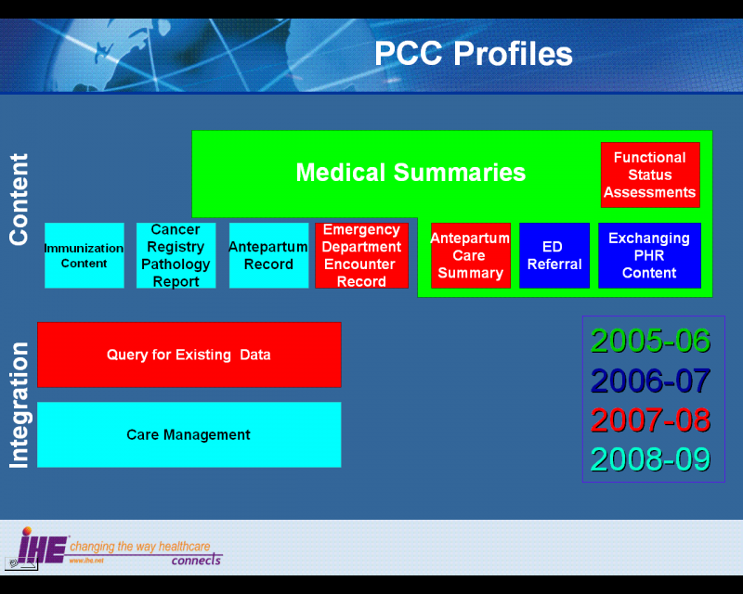
Figure 2.4-1 IHE Patient Care Coordination Content Integration Profiles

Dependencies of the PCC Integration Profiles
Dependencies among IHE Integration Profiles exist when implementation of one integration profile is a prerequisite for achieving the functionality defined in another integration profile. The table below defines these dependencies. Some dependencies require that an actor supporting one profile be grouped with one or more actors supporting other integration profiles. For example, Cross-Enterprise Sharing of Medical Summaries (XDS-MS) requires that its actors be grouped with a Secured Node Actor of the Audit Trail and Node Authentication (ATNA) Integration Profile. The dependency exists because XDS-MS and XDS actors must support a secured communication channel with proper auditing of the exchange of patient identified information in order to function properly in an environment where protection of patient privacy is critical.

Integration Profile | Depends on | Dependency Type | Purpose
All PCC Content Profiles | Audit Trail and Node Authentication (ATNA) | Each Content Creator and Content Consumer actor shall be grouped with the ATNA Secured Node Actor | Required to manage audit trail of exported PHI, node authentication, and transport encryption.
All PCC Content Profiles | Consistent Time (CT) | Each Content Creator and Content Consumer actor shall be grouped with the Time Client Actor | Required to manage and resolve conflicts in multiple updates.
Functional Status Assessments (FSA) | Cross Enterprise Document Exchange of Medical Summaries (XDS-MS)  OR  Exchange of Personal Health Record Content (XPHR)  OR  Emergency Department Referral (EDR) | Content Consumers implementing the Functional Status Assessments profile shall be grouped with either the XDS-MS, XPHR or EDR Content Consumer. Content Creators implementing the Functional Status Assessments profile shall be grouped with either the XDS-MS, XPHR or EDR Content Creator. | Ensures that the Functional Status Assessment is communicated as part of an exchange of medical summary information.
Functional Status Assessments (QED) | Audit Trail and Node Authentication (ATNA) | Each actor in this profile shall be grouped with the ATNA Secure Node or Secure Application actor. | Required to manage audit trail of exported PHI, node authentication, and transport encryption.
Functional Status Assessments (QED) | Consistent Time (CT) | Each actor in this profile shall be grouped with the Time Client Actor | Required to manage and resolve conflicts in multiple updates.
Table 1.1.5-1 PCC Profile Dependencies
To support a dependent profile, an actor must implement all required transactions in the prerequisite profiles in addition to those in the dependent profile. In some cases, the prerequisite is that the actor selects any one of a given set of profiles.

PCC Integration Profiles Overview
In this document, each IHE Integration Profile is defined by:
- The IHE actors involved
- The specific set of IHE transactions exchanged by each IHE actor.
- The content of the IHE transactions
These requirements are presented in the form of a table of transactions required for each actor supporting the Integration Profile. Actors supporting multiple Integration Profiles are required to support all the required transactions of each Integration Profile supported. When an Integration Profile depends upon another Integration Profile, the transactions required for the dependent Integration Profile have not been included in the table.
The content of the transactions are presented as Content Integration Profiles. These are specification of the content to be exchange, along with explanations (called bindings) of how the content affects the transactions in which it is exchanged. It is expected that Content Integration Profiles will be used environments where the physician offices and hospitals have a coordinated infrastructure that serves the information sharing needs of this community of care. Several mechanisms are supported by IHE profiles:
- A registry/repository-based infrastructure is defined by the IHE Cross-Enterprise Document Sharing (XDS) and other IHE Integration Profiles such as patient identification (PIX & PDQ), and notification of availability of documents (NAV).
- A media-based infrastructure is defined by the IHE Cross-Enterprise Document Media Interchange (XDM) profile.
- A reliable messaging-based infrastructure is defined by the IHE Cross-Enterprise Document Reliable Interchange (XDR) profile.
- All of these infrastructures support Security and privacy through the use of the Consistent Time (CT) and Audit Trail and Node Authentication (ATNA) profiles.
For more details on these profiles, see the IHE IT Infrastructure Technical Framework, found here: http://www.ihe.net/Technical_Framework/.
Such an infrastructure is assumed by the use cases that focus on the context for defining the specific clinical information content for this profile. These content integration profiles use similar transactions and differ only in the content exchanged. A process flow for these use cases using Cross Enterprise Document Sharing (XDS) and Notification of Document Availability (NAV) is shown in the figure below. Other process flows are possible using XDM and/or XDR.
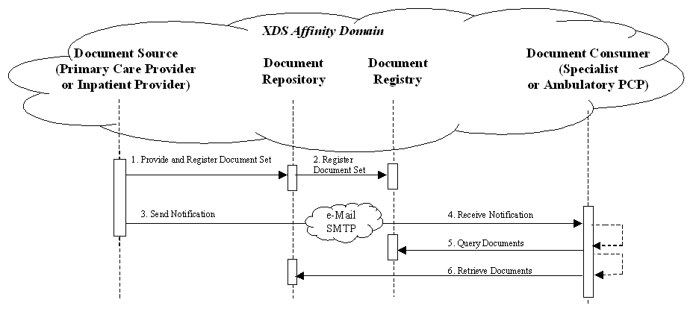
Figure 2.6-2 Use Case Process Flow Diagram
These steps are:
- Extract/capture a collection of records into a set of documents packaged as an XDS Submission Set. This submission contains at least one clinical document, and may contain a number of other related clinical documents. For example, Medical Summaries are clinical documents (already known in the paper world), which often serve the dual purpose of documenting an encounter and providing the rationale for sending the information to another provider. This step utilizes the transactions provided by the ITI XDS profile to place the records in an XDS Repository (local or shared).
- The Repository ensures that the documents of the submission set are registered with the XDS Registry of the Affinity Domain (set of cooperating care delivery institutions).
- Notify the other provider that documents are now available for review. This step utilizes the transactions provided by the ITI NAV profile to perform the e-mail notification.
- The e-mail notification that contains no patient identified information is received by the specialist EMR system.
- The receiving provider can then utilize existing query transactions from the XDS profile to find the URL of the Documents.
- Finally, the receiving provider may choose to display the document, or import relevant information from these records into their own EMR system.

Unplanned Access to past Content
In many cases, a provider may need to assess information from the patient care history, and patients may have content in the XDS repository from prior visits to other providers. For example, Medical Summaries, as well as other documents such as laboratory and radiology reports are critical for emergency physicians and nurses to provide the best care to patient in acute conditions. The figure below shows the transactions required for this use case, again, using XDS. Other process flows are possible using XDM and/or XDR.
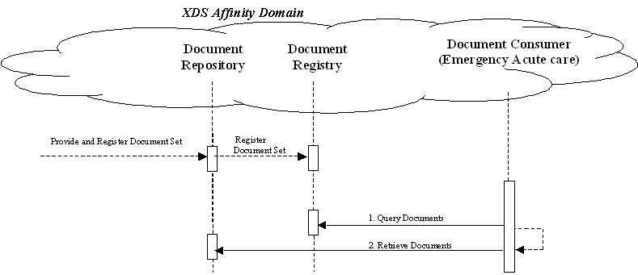
Figure 2.6-3 Unplanned Access Process Flow Diagram

Note that IHE Integration Profiles are not statements of conformance to standards, and IHE is not a certifying body. Users should continue to request that vendors provide statements of their conformance to standards issued by relevant standards bodies, such as HL7 and DICOM. Standards conformance is a prerequisite for vendors adopting IHE Integration Profiles.
Also note that there are critical requirements for any successful integration project that IHE cannot address. Successfully integrating systems still requires a project plan that minimizes disruptions and describes fail-safe strategies, specific and mutually understood performance expectations, well-defined user interface requirements, clearly identified systems limitations, detailed cost objectives, plans for maintenance and support, etc.

History of Annual Changes
In the 2005-2006 cycle of the IHE Patient Care Coordination initiative, the first release of the IHE PCC Technical Framework introduced the following integration profile:
- Cross-Enterprise Sharing of Medical Summaries (XDS-MS) – a mechanism to automate the sharing process between care providers of Medical Summaries, a class of clinical documents that contain the most relevant portions of information about the patient intended for a specific provider or a broad range of potential providers in different settings. Medical Summaries are commonly created and consumed at points in time of transfers of care such as referrals or discharge.
In the 2006-2007 cycle of the IHE Patient Care Coordination initiative, the following integration profiles were added to the technical framework.
- Exchange of Personal Health Record Content (XPHR) – provides a standards-based specification for managing the interchange of documents between a Personal Health Record used by a patient and systems used by other healthcare providers to enable better interoperability between these systems.
- Basic Patient Privacy Consents (BPPC) – enables XDS Affinity Domains to be more flexible in the privacy policies that they support, by providing mechanisms to record patient privacy consents, enforce these consents, and create Affinity Domain defined consent vocabularies that identify information sharing policies.
Please Note: This profile was transferred to the ITI Domain in the Fall of 2007, and can be found here http://www.ihe.net/Technical_Framework/index.cfm#IT
- Pre-procedure History and Physical Content Profile (PPHP) – supports the exchange of information allowing for the assessment and amelioration of risks related to a procedure. Please Note: This profile has been withdrawn.
- Emergency Department Referral Profile (EDR) – provides a means to communicate medical summary data from an EHR System to an EDIS System.
In the 2007-2008 cycle of the IHE Patient Care Coordination initiative, the following integration profiles were added to the technical framework.
- Antepartum Care Summary (APS) - describes the content and format of summary documents used during Antepartum care.
- Emergency Department Encounter Summary (EDES) - describes the content and format of records created during an emergency department visit.
- Functional Status Assessment Profile (FSA) - supports the handoff of assessment information between practitioners during transfers of care by defining the Functional Status Assessment option on the XDS-MS and XPHR profiles.
- Query for Existing Data (QED) - allows information systems to query data repositories for clinical information on vital signs, problems, medications, immunizations, and diagnostic results.
- Public Health Laboratory Report (PHLAB) - extends the XD*-LAB profile to support reporting from public health laboratories for disease surveillance activities. Please Note: This profile has been subsequently moved to the XD-LAB specification, and van be found here http://www.ihe.net/Technical_Framework/index.cfm#LAB
In addition, all content within the technical framework was revised in the 2007-2008 cycle to encourage compatibility with the ASTM/HL7 Continuity of Care Document Implementation Guide.
In the 2008-2009 cycle of the IHE Patient Care Coordination initiative, the following integration profiles were added to the technical framework.
- Antepartum Record (APR) - describes the content and format of summary documents used during Antepartum care.
- Care Management (CM) - provides a mechanism for EHR and other HIT systems to communicate information to Care Management systems in support of specialized care programs through the use of evidence based guidelines.
- Immunization Content (IC) - defines standard immunization data content for Immunization Information Systems (IISs), other public health systems, electronic medical records (EMR) systems, Health Information Exchanges, and others wishing to exchange immunization data electronically in a standard format.
- Cancer Registry Pathology Report (CPR) - describes the content used in PCC-11 to send a completed pathology report to a Cancer Registry using an HL7 Version 2.3.1 ORU message.

Product Implementations
Developers have a number of options in implementing IHE actors and transactions in product implementations. The decisions cover three classes of optionality:
- For a system, select which actors it will incorporate (multiple actors per system are acceptable).
- For each actor, select the integration profiles in which it will participate.
- For each actor and profile, select which options will be implemented.
All required transactions must be implemented for the profile to be supported (for XDS-MS, refer to the transaction descriptions for XDS in ITI TF-2).
Implementers should provide a statement describing which IHE actors, IHE integration profiles and options are incorporated in a given product. The recommended form for such a statement is defined in PCC TF-1: Appendix C.
In general, a product implementation may incorporate any single actor or combination of actors. When two or more actors are grouped together, internal communication between actors is assumed to be sufficient to allow the necessary information flow to support their functionality; for example, the Document Source Actor of XDS-MS may use the Patient Identifier Cross-reference Consumer Actor to obtain the necessary patient identifier mapping information from its local patient id to that used in the document sharing domain. The exact mechanisms of such internal communication are outside the scope of the IHE Technical Framework.
When multiple actors are grouped in a single product implementation, all transactions originating or terminating with each of the supported actors shall be supported (i.e., the IHE transactions shall be offered on an external product interface).
The following examples describe which actors typical systems might be expected to support. This is not intended to be a requirement, but rather to provide illustrative examples.
An acute care EMR serving a hospital might include a Document Source Actor, Document Consumer Actor, a Document Repository Actor, a Patient Identification Consumer Actor, as well as a Secured Node Actor. An Ambulatory EMR serving a physician practice might include a Document Source Actor, Document Consumer Actor, a Patient Demographics Client Actor, as well as a Secured Node Actor.

Pre-Hospital Patient Care Report (PCR)
This is a draft of the Pre-Hospital Patient Care Report (PCR) supplement to the PCC Technical Framework. This draft is a work in progress, not the official supplement or profile.

Open Issues
- How do you handle the electronic integration of ECON / PHR data into EMS pre-hospital patient care reporting (PCR) systems supporting real-time messaging of motor vehicle crash victim ECON / PHR data to emergency department clinicians?

Closed Issues
- Template for on-scene Law Enforcement to hand over motor vehicle crash victim identity (ID) and emergency contact information (ECON) to EMS providers in an automated format at the scene of an incident. Obtaining positive ID for a crash victim is a critical and essential step to enabling the balance of on-scene EMS transactions, including querying for the location of a crash victim PHR (IHE PDQ) and then querying the needed documents (IHE XDS) and retrieving a ‘short list’ of pre-existing conditions, medications, allergies, as well as, supporting patient care report (PCR) registration and real-time messaging of crash victim deomographics (IHE PAM) to emergency department clinicians.

Profile Abstract
The Pre-Hospital Patient Care Report (PCR) Profile improves the quality of emergency care for motor vehicle crash victims by reducing the continuing reliance by many emergency responders and emergency room clinicians on archaic, paper-based methods of communicating crash victim key health information, such as emergency contact information (ECON) and personal health record (PHR) data. The Pre-Hospital Patient Care Report (PCR) Profile is based upon the HHS approved HITSP Emergency Responder IS-04 Use Case which includes the following ER-EHR On Site Care Component Model:
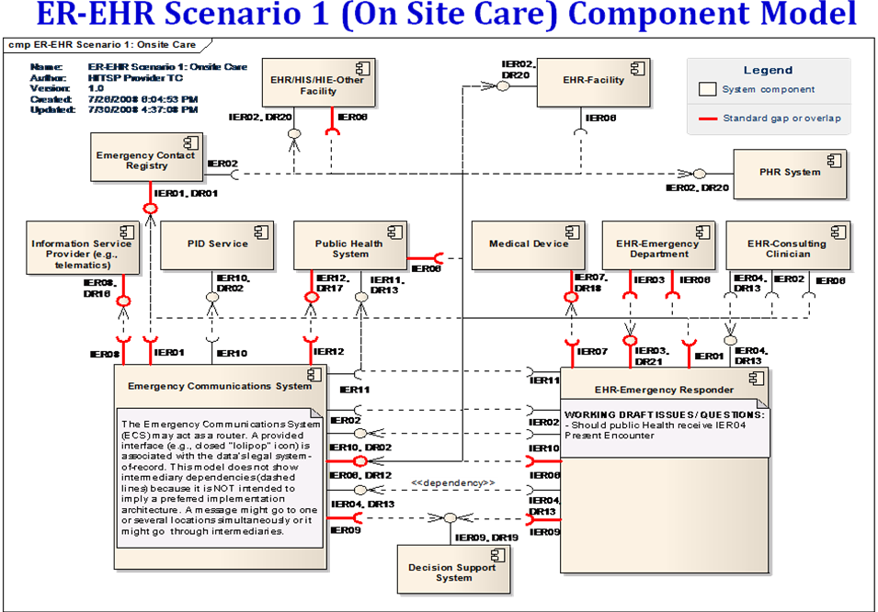

Dependencies
Add the following row(s) to the list of dependencies
Integration Profile | Dependency | Dependency Type | Purpose
Pre-Hospital Patient Care Report

Overview
There is consensus among the emergency health care community that the widespread adoption of Health Information Technology (HIT) by emergency responders at the scene of a motor vehicle crash holds the promise to improve post-crash care and survivability for crash victims on our nation’s roadways.
The quid pro quo for developing and deploying emergency responder on-scene HIT systems is the improvement of safety, care, and outcomes for the nearly 250,000 crash victims (6,000,000 worldwide) who sustain life-threatening injuries annually as a result of motor vehicle crashes.
Persistent deficiencies in the quality of emergency health care for motor vehicle crash victims is attributable in part to the continued reliance by many emergency responders and emergency room clinicians on archaic, paper-based methods of communicating crash victim key health information, such as Emergency Contact Information (ECON) and Personal Health Record (PHR) data.
Under a worst-case scenario, an emergency responder at the scene of a motor vehicle crash attempting to stabilize an unconscious crash victim or an emergency room clinician attempting to treat an unconscious crash victim would have no idea what pertinent medical conditions the crash victim might have or which medications he or she might be taking, nor contact information for an emergency contact / next-of-kin who might be able to provide such data. This lack of data increases the risks of adverse reactions to treatment or medication that threaten the safety, care, and outcome for crash victims.

Use Case

Use Case 1: Pre-Hospital Patient Care Report – Integration and Reporting of Emergency Responder Electronic Health Record (ER-EHR) Use Case Data
This use case reflects the course of EMS on-scene care for a patient involved in a motor vehicle crash.

Pre-condition
A patient has voluntarily pre-registered a ‘vehicular emergency data set’ in a federated law enforcement database for the specific purpose of such data set being immediately available to emergency responders following a motor vehicle crash. The ‘vehicular emergency data set’ is linked to a 17-digit vehicle identification number (VIN#) and/or driver’s license number (DL#). The ‘vehicular emergency data set’ collected in the federated law enforcement database include:

- Patient demographics
- Emergency contact information (ECON)
- Electronic pointer to the availability of a personal health record (PHR)
The information collected voluntarily from the patient make up the ‘vehicular emergency data set’.
Event(s)
1.) A patient is involved in a motor vehicle crash and rendered unconscious.
2.) Police are first to arrive on the scene
(a) Police utilize the vehicle identification number (VIN#) as a unique identifier to query a federated emergency contact registry operated and managed by the National Law Enforcement Telecommunications System (Nlets) to obtain the vehicle owner emergency contact name(s) and phone numbers(s) (i.e., VIN# ECON dataset). Vehicle owner emergency contacts provide assistance in identifying unidentified crash victims, as well as, provide additional knowledge about certain aspects of victim-specific health information, such as pre-existing conditions, allergies, medications, primary care physician, etc. (See HITSP Emergency Responder Electronic Health Record Interoperability Specification “ER-EHR IS-04”)
3.) An EMS unit is dispatched to the scene
(a) Police electronically pass gathered patient identity (ID) and vehicular emergency data set to EMS. The gathered information may include an electronic pointer to the availability and location of a Personal Health Record (PHR).
(b) EMS electronically records the Patient ID, ECON, and PHR ‘pointer’ information in the Pre-Hospital Patient Care Report (PCR) system, enabling EMS to send a query (or automatically query a Patient Identification Service) to determine the location of the PHR and/or EHR data. (See IHE ITI ID/ECON White Paper “Template for Law Enforcement to Hand Over Crash Victim Identity (ID) and Emergency Contact Information (ECON) to EMS Providers Following a Motor Vehicle Crash”).
4.) EMS provides personalized care to stabilize patient and treat for injuries.
(a) Treatment details are recorded in the PCR system.
5.) Patient is transported to the nearest hospital emergency department.
(a) Transport details are recorded in the PCR system.
6.) Police utilize VIN# ECON information to expedite family member reunification and/or next-of-kin notification.
7.) Upon arrival of the patient to the Emergency Department, treatment for injuries continues.
(a) EMS (PCR) of the treatment, personal health information, emergency contact info. / next-of-kin data, is provided upon delivery to the facility.
8.) EMS personnel complete their run report, and information in the PCR is used to electronically update the Emergency Department Information System (EDIS).
9.) Emergency Department personnel utilize VIN# ECON information in EDIS to contact family members to obtain more information about the patient and facilitate family member reunification.
10.) Family members arrive at hospital.
Post-condition
???????????????????

Actors/Transaction
There are two actors in this profile, the Content Creator and the Content Consumer. Content is created by a Content Creator and is to be consumed by a Content Consumer. The sharing or transmission of content from one actor to the other is addressed by the appropriate use of IHE profiles described below, and is out of scope of this profile. A Document Source or a Portable Media Creator may embody the Content Creator Actor. A Document Consumer, a Document Recipient or a Portable Media Importer may embody the Content Consumer Actor. The sharing or transmission of content or updates from one actor to the other is addressed by the use of appropriate IHE profiles described by section 3.7 Content Bindings with XDS, XDM and XDR found in the Patient Care Coordination Technical Framework

Figure 3.6-4 Antepartum Record Actor Diagram

Options
Actor | Option | Section
Content Consumer | View Option (See Note 1)  Document Import Option (See Note 1)  Section Import Option (See Note 1)  Discrete Data Import Option (See Note 1) | PCC TF-1: 2.13.1  PCC TF-1: 2.13.2  PCC TF-1: 2.13.3  PCC TF-1: 2.13.4
Content Creator | Referral Option (See Note 1)  Discharge Summary Option (See Note 1) | PCC TF-1: 2.13.5  PCC TF-1: 2.13.6
Note 1: The Actor shall support at least one of these options.

Grouping

Content Bindings with XDS, XDM and XDR
It is expected that the transfers of care will occur in an environment where the physician offices and hospitals have a coordinated infrastructure that serves the information sharing needs of this community of care. Several mechanisms are supported by IHE profiles:
- A registry/repository-based infrastructure is defined by the IHE Cross Enterprise Document Sharing (XDS) and other IHE Integration Profiles such as patient identification (PIX & PDQ) and notification of availability of documents (NAV).
- A media-based infrastructure is defined by the IHE Cross Enterprise Document Media Interchange (XDM) profile.
- A reliable messaging-based infrastructure is defined by the IHE Cross Enterprise Document Reliable Interchange (XDR) profile.
- All of these infrastructures support Security and privacy through the use of the Consistent Time (CT) and Audit Trail and Node Authentication (ATNA) profiles.
For more details on these profiles, see the IHE IT Infrastructure Technical Framework. Content profiles may impose additional requirements on the transactions used when grouped with actors from other IHE Profiles.

Cross Enterprise Document Sharing, Media Interchange and Reliable Messages
Actors from the ITI XDS, XDM and XDR profiles embody the Content Creator and Content Consumer sharing function of this profile. A Content Creator or Content Consumer must be grouped with appropriate actors from the XDS, XDM or XDR profiles, and the metadata sent in the document sharing or interchange messages has specific relationships to the content of the clinical document described in the content profile.

Notification of Document Availability (NAV)
A Document Source should provide the capability to issue a Send Notification Transaction per the ITI Notification of Document Availability (NAV) Integration Profile in order to notify one or more Document Consumer(s) of the availability of one or more documents for retrieval. One of the Acknowledgement Request options may be used to request from a Document Consumer that an acknowledgement should be returned when it has received and processed the notification. A Document Consumer should provide the capability to receive a Receive Notification Transaction per the NAV Integration Profile in order to be notified by Document Sources of the availability of one or more documents for retrieval. The Send Acknowledgement option may be used to issue a Send Acknowledgement to a Document Source that the notification was received and processed.

Document Digital Signature (DSG)
When a Content Creator Actor needs to digitally sign a document in a submission set, it may support the Digital Signature (DSG) Content Profile as a Document Source. When a Content Consumer Actor needs to verify a Digital Signature, it may retrieve the digital signature document and may perform the verification against the signed document content.

Content Modules
Content modules describe the content of a payload found in an IHE transaction. Content profiles are transaction neutral. They do not have dependencies upon the transaction that they appear in.

Pre-Hospital Patient Care Report

???????????

???????????

???????????

Process Flow
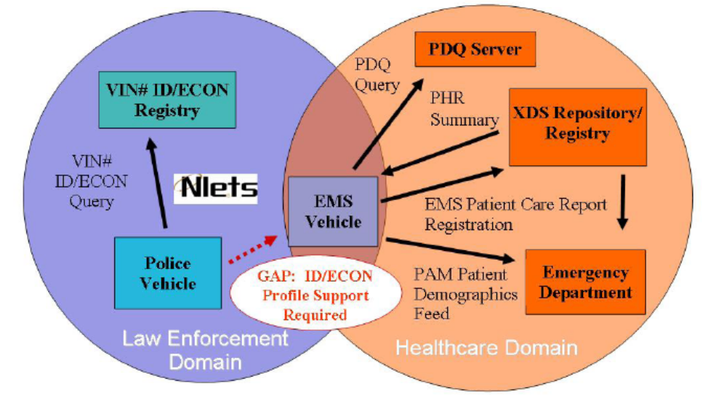

Figure 3.10-5 Pre-Hospital Patient Care Report Process Flow
This process flow diagram shows the movement of the ‘vehicular emergency data set’ over the course of care for a motor vehicle crash victim involving a police vehicle, an EMS vehicle, and an emergency department. This diagram specifically excludes other infrastructure interactions for simplicity and readability. These infrastructure interactions may be found elsewhere in the framework.
Data from the motor vehicle crash victim’s ‘vehicular emergency data set’ aggregates into the pre-hospital patient care report by the EMS provider. The pre-hospital patient care report is then sent to the emergency department.
Actor Descriptions
Actors are information systems or components of information systems that produce, manage, or act on information associated with operational activities in the enterprise.
Content Creator
The Content Creator Actor is responsible for the creation of content and transmission to a Content Consumer.
Content Consumer
A Content Consumer Actor is responsible for viewing, import, or other processing of content created by a Content Creator Actor.
Transaction Descriptions
Transactions are interactions between actors that transfer the required information through standards-based messages.
How to Prepare an IHE Integration Statement
IHE Integration Statements are documents prepared and published by vendors to describe the conformance of their products with the IHE Technical Framework. They identify the specific IHE capabilities a given product supports in terms of IHE actors and integration profiles described in the technical frameworks of each domain.
Users familiar with these concepts can use Integration Statements to determine what level of integration a vendor asserts a product supports with complementary systems and what clinical and operational benefits such integration might provide. Integration Statements are intended to be used in conjunction with statements of conformance to specific standards (e.g. HL7, IETF, DICOM, W3C, etc.).
IHE provides a process for vendors to test their implementations of IHE actors and integration profiles. The IHE testing process, culminating in a multi-party interactive testing event called the Connect-a-thon, provides vendors with valuable feedback and provides a baseline indication of the conformance of their implementations. The process is not intended to independently evaluate, or ensure, product compliance. In publishing the results of the Connect-a-thon and facilitating access to vendors' IHE Integration Statements, IHE and its sponsoring organizations are in no way attesting to the accuracy or validity of any vendor's IHE Integration Statements or any other claims by vendors regarding their products.
IMPORTANT -- PLEASE NOTE: Vendors have sole responsibility for the accuracy and validity of their IHE Integration Statements. Vendors' Integration Statements are made available through IHE simply for consideration by parties seeking information about the integration capabilities of particular products. IHE and its sponsoring organizations have not evaluated or approved any IHE Integration Statement or any related product, and IHE and its sponsoring organizations shall have no liability or responsibility to any party for any claims or damages, whether direct, indirect, incidental or consequential, including but not limited to business interruption and loss of revenue, arising from any use of, or reliance upon, any IHE Integration Statement.
  - Structure and Content of an IHE Integration Statement
An IHE Integration Statement for a product shall include:
- The Vendor Name
- The Product Name (as used in the commercial context) to which the IHE Integration Statement applies.
- The Product Version to which the IHE Integration Statement applies.
- A publication date and optionally a revision designation for the IHE Integration Statement.
- The following statement: "This product implements all transactions required in the IHE Technical Framework to support the IHE Integration Profiles, Actors and Options listed below:"
- A list of IHE Integration Profiles supported by the product and, for each Integration Profile, a list of IHE Actors supported. For each integration profile/actor combination, one or more of the options defined in the IHE Technical Framework may also be stated. Profiles, Actors and Options shall use the names defined by the IHE Technical Framework Volume I. (Note: The vendor may also elect to indicate the version number of the Technical Framework referenced for each Integration Profile.)
Note that implementation of the integration profile implies implementation of all required transactions for an actor as well as selected options. The statement shall also include references and/or internet links to the following information:
- Specific internet address (or universal resource locator [URL]) where the vendor's Integration Statements are posted
- URL where the vendor's standards conformance statements (e.g., HL7, DICOM, etc.) relevant to the IHE transactions implemented by the product are posted.
- URL of the IHE Initiative's web page for general IHE information www.himss.org/ihe.
An IHE Integration Statement is not intended to promote or advertise aspects of a product not directly related to its implementation of IHE capabilities.
  - Format of an IHE Integration Statement
Each Integration Statement shall follow the format shown below. Vendors may add a cover page and any necessary additional information in accordance with their product documentation policies.
IHE Integration Statement | Date | 12 Oct 2005
Vendor | Product Name | Version
Any Medical Systems Co. | IntegrateRecord | V2.3
This product implements all transactions required in the IHE Technical Framework to support the IHE Integration Profiles, Actors and Options listed below:
Integration Profiles Implemented | Actors Implemented | Options Implemented
Cross-Enterprise Sharing of Medical Summaries | Document Consumer | View Option
Audit Trail and Node Authentication | Secure Node | none
Patient Identity Cross-referencing | Patient Identifier Cross-reference Consumer | PIX Update Notification
Internet address for vendor's IHE information:www.anymedicalsystemsco.com/ihe
Links to Standards Conformance Statements for the Implementation
HL7 | www.anymedicalsystemsco.com/hl7
Links to general information on IHE
In North America: www.ihe.het | In Europe: www.ihe-europe.org | In Japan: www.jira-net.or.jp/ihe-j
The assumption of an integration statement is that all actors listed are functionally grouped and conform to any profile specifications for such groupings. In case of exceptions the vendor must explicitly describe the functional groupings.

Glossary

